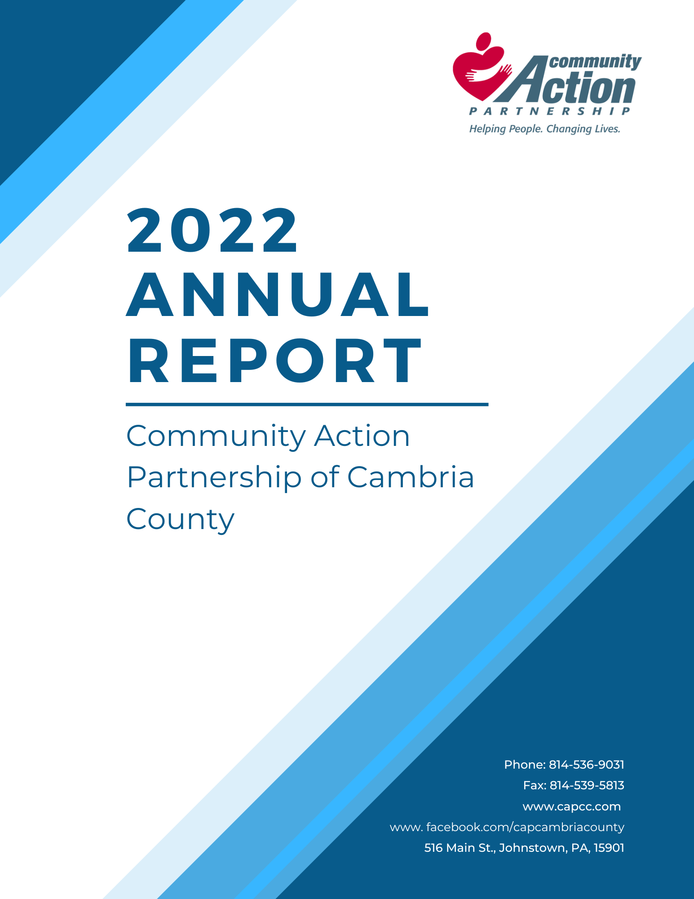

*Mission Statement*

*The Community Action Partnership of Cambria County works with eligible individuals and families to improve their quality of life by offering advocacy, services, and support.*

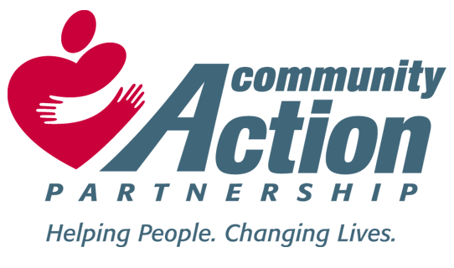

*Message from the Executive Director*

The agency has continued to provide quality services to our clients in Cambria County on a regular basis. Our Community HUB program has grown and expanded significantly over the last two years with high caseloads, more community health workers and managed care funding as well. We have also received an increase in community donations to our various projects such as the veterans backpack, Christmas families, baby bundle and so on. We appreciate the ongoing support from our community with these efforts.

This year’s annual awards banquet was held at the Holiday Inn downtown, celebrating our 56th year of service as an agency. Community, Board, and employee awards were presented, and everyone was recognized for their years of service and commitment to the agency.

Our Board of Directors continues to remain active and engaged in the agency’s activities and has gained new members this past year which has allowed new ideas, new thinking, and new discussions to routine issues. We welcome these new members and continue to thank our existing members for their hard work and dedicated service all year long. The Board cares about our programs, our staff, and the clients we serve.



*Jeffery L. Vaughn MSW, LSW*

*Executive Director*

*Financial Information*



*2022 Audit*

*Completed by*

*Kotzan CPA and Associates*

*Johnstown, PA*

*Board of Directors*

PUBLIC OFFICIALS

Commissioner William Smith

Commissioner Scott Hunt

Paula Tomko Representing Commissioner Tom Chernisky

Kelley Peters Representing State Senator Wayne Langerholc Jr.

Mary Lauf Representing State Representative Jim Rigby

Kristine Segear Representing Ed Cernic Jr.

**VACANCY**

PRIVATE ORGANIZATIONS

Josh Yoder CAMTRAN Chief Operating Officer

Daniel Hooper First National Bank

Natalie Kauffman Cambria County Drug Coalition

Ian Banks Remax Realty

Barb Penna Senior Life Marketing Director

Christina Baughman Cambria County Child Development

**VACANCY**

COMMUNITY SECTOR

Ed Porada Representing Rural Area

Jennifer Wyant Representing Rural Area

Anthony Penna Sr.  Representing Urban Area

Tania Jerome Representing Urban Area

Adrienne Rosmus Representing Rural Area

**VACANCY**

Nicole Farabaugh Representing Head Start Policy Council

*Administration*

**Management Team**

**Jeffery Vaughn, Executive Director**

**Hannah Rottman, CFO**

**Rita Wasnick, HR Director**

**Helen Robinson, Community Services Director**

**Ann Kelly, Early Childhood Director**

**Melina Hudec, WIC Program Director**



*Community Services*

**MATP – Medical Assistance Transportation Program –** This program, designed to help people who have the Medical Access card get to their medical appointments, continues to grow as more clients sign up. The transportation services are provided in three ways; mass transit, personal reimbursement for driving their own vehicles, and para-transit services provided by subcontracted transportation companies. In total, we helped to provide **89,442** trips to **2,172** clients in our area. The service chosen for each client is based on the most cost-effective manner that suits the medical needs of the client.

**DHS – (Department of Human Services) Rental Assistance Program -** This program (200% of poverty) is in place to address the needs of the homeless or nearly homeless in our community. Low-income families facing eviction or having no place to live are eligible for funds to get into housing or prevent eviction. This year we were able to help **435** people with their housing crises.  **350** individuals were assisted with evictions and **85** were assisted with homelessness.

**FEMA – (Federal Emergency Management Agency) Rental Assistance Program –** This program (200% of poverty) helps the homeless or nearly homeless. Families meeting the requirements for this program are assisted with one month’s housing costs. We were able to help **100** people with these funds in the last year. **71** of these were evictions and **29** were homeless.

**ESG – (Emergency Solution Grant) -** This program is designed for “New Homeless” segment of our community. It can provide short term rental and utility assistance with an intensive case management component. Income guidelines are based on 30% of area median income. In the last year we have helped **10** people with rental assistance.

**Housing Case Management** services are provided to all clients who receive housing assistance. The income management and referral process include one group session and one private session with a Case Manager to assess needs and set goals. Services can become longer term. Despite few Rent Assistance clients being waived for this service and the fact that further rent assistance is denied for two years for failure to complete Case Management, only about one third of the clients referred had positive completions. Of all the housing clients served this year **350** of them benefitted from case management.

**Community Health Worker – Center for Population Health (CHW-CPH) -** If a Cambria or Somerset County resident is pregnant and diagnosed with Gestational Diabetes or eligible for Medical Assistance they qualify for free services. It has grown in the last year to include families in the Greater Johnstown School who have social determinants of health needs and individuals with conditions like diabetes and substance use disorders with direct referrals from the insurers. This program is designed to impact health outcomes by addressing risk factors associated with poor health outcomes. The community health workers meet with participants face-to-face, preferably in their homes, then guide them through one or more of 21 Pathways designed to address their needs. It involves the collaboration of all community resources to reduce both medical and social barriers to care, like employment, housing, and transportation, for individuals with complex health needs. We enrolled and assisted **122** clients in the last year.

**$1 Energy Program-** Is designed to assist Peoples Natural Gas and Penelec customers (200% of poverty) whose gas or electric service has been shut off or is under termination; after March 1st they will assist all low-income clients until funds are depleted. The Dollar Energy Customers must have applied for LIHEAP and made a qualifying payment to the utility to be eligible Dollar Energy. We were able to help **6** low-income clients with their applications this year.

**Emergency Assistance Program (EAP-CSBG)** **–** This program is to help clients with emergency situations throughout the year. Eligible clients under the 125% of poverty guidelines can be helped with up to $250 per family was available. In the last year we helped **34** clients with medical related issues including medically beneficial air conditioners.

We were able to assist **19** people with deliverable fuels. We also assisted **23** people with transportation and **16** people with a variety of other services ranging from refrigerators, hot water heaters and other services.

**Client Emergency Assistance Services – (CEAP-CSBG)** This program is forclients who need some assistance that makes it possible for them to begin employment. Such assistance can be transportation, uniforms or special clothing, licensing fees or other short-term support. Verification of employment for at least twenty hours per week must be provided by the employer. Clients do need to be eligible under the 125% of Federal Poverty Guidelines. **Nineteen** clients were helped with ID’s, background clearances and birth certificates. An additional **2** clients were assisted in this fiscal year with transportation to work and clothing items to start work.

**Veteran’s Backpack Program (VBP)** – This program was introduced to help veterans with toiletries as they left homeless shelters. We were able to help **86** veterans with this. It has grown to include all veteran’s experiencing a crisis in their life. We helped an additional **20** veterans and their families with emergencies. It is all done with donated dollars specifically targeted to help veterans.

**Helen Robinson, Community Services Director**



*Early Childhood Programs*

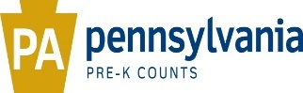

# Federal and State Funding

During the 2021-2022 Program Year, CAPCC Early Childhood Programs received a total of

$5,268,488 with $4,051,015 for the Head Start Program, $257,671 for the Early Head Start Program, $198,552 for the Head Start State Supplemental Assistance Program (HSSAP), and $761,250 for the Pennsylvania Pre-K Counts Program.

# Budgets and Budgetary Expenditures

Federal Head Start Total including T & TA: $4,051,015 (Training and Technical Assistance: $44,929)

Non-Federal Share Required: $1,000,683 (Short $220,000 - Waiver Approved)

Due to staffing shortages and supply chain issues $257,177.64 of federal funding was approved for carryover into the 2022 -2023 program year.

Federal Early Head Start Total including T & TA: $257,671 (Training and Technical Assistance: $7,177)

Non-Federal Share Required: $63,663

Head Start State Supplemental Assistance Program (HSSAP): $198,552

Pennsylvania Pre-K Counts Program (PKC): $761,250

# Mount Aloysius, Johnstown, Northern Cambria, Salix and Admiral Peary Federal Head Start and Head Start State Supplemental Assistance Program Funding Enrollment

Head Start remained fully enrolled this program year with a cumulative enrollment total of **326** students receiving services through Federal Head Start and the Head Start State Supplemental Assistance Program (HSSAP) funding. These students range in ages from 3 to 5 years old and live throughout Cambria County. Specifically, 136 students were age 4 years upon enrollment and 190 students were age 3 years at the time of their enrollment into the program.

The funded enrollment slots through the Federal Head Start grant was for 311 students and the Pennsylvania Head Start Supplemental Assistance grant (HSSAP) was for 18 students. The cumulative enrollment total outlined above was lower than the funded enrollment due to limiting classroom enrollment after the start the program year due to an uptick of positive COVID cases and quarantines due exposures. At that time there was no vaccine available to the age group of the children that we serve in our preschool classrooms. For the safety of our children, enrollment in our Head Start classrooms was capped at 15 to enable staff and children to social distance.

Our monthly enrollment totals remained slowly declined through the end of the program year as children who dropped were not replaced until the classroom enrollment level dropped below the capped level of 15 children.

Our waiting lists remained moderate at every center site location - the numbers fluctuated according to family need, area population, and the availability of other preschool programs in the community.

# Early Head Start in Northern Part of Cambria County

This was the seventh year we provided Early Head Start Home Based Services in the northern part of Cambria County. The county was divided by zip codes and serviced by either Professional Family Care Services (PFCS) or our agency (CAPCC). A strong collaboration was formed and continues between these agencies/providers. Early Head Start remained fully enrolled this program year with a cumulative enrollment total of **39** pregnant women/students birth to age 3 receiving services through Federal Early Head Start (EHS) funding. Specifically, 1 pregnant women, 10 students under 1 year of age, 12 one-year olds, 14 two-year olds, and 3 three-year olds at the time of their enrollment into the program.

The funded enrollment slots through the Federal Early Head Start grant was for 24 pregnant women/students. However, the cumulative enrollment total outlined above was higher than the funded enrollment due to students transitioning to a Preschool Program, such as Head Start and dropouts and fill-ins throughout the program year.

Our monthly enrollment totals remained stable with full enrollment (100%), as is required by Federal Performance Standards.

Our waiting list remained minimal for this program with socialization in the northern part of Cambria County.

# Additional State Funding Enrollment

CAPCC Early Childhood also provides Preschool Services through the **Pennsylvania Pre-K Counts Grant**. This program offers high quality preschool services at no cost to eligible families in Cambria County.

During the 2021-2022 Program Year, CAPCC Pre-K Counts provided 94 students (enrollees and dropouts/fill-ins included) ages 3 to 5 years, services through **5 different site locations** – Johnstown City, Salix, Cambria Elementary, Jackson Elementary and Westmont Hilltop Elementary. Specifically, 51 students were 4 years old and 43 students were 3 years old based upon the school cutoff dates and enrollment into the program.

# Program Eligibility

**Head Start, Head Start Supplemental, and Early Head Start** families must meet the income eligibility requirements which equals, at or below **federal poverty-level guidelines**, (i.e., in 2021, a family of 4 can earn up to $26,500 at 100% poverty level).

The Head Start Act of 2007 passed an enactment that allows Head Start/Early Head Start programs to award an additional 25% of enrollment slots to families who meet the 130% federal poverty guidelines (i.e., in 2021, a family of 4 could earn up to $34,450).

Therefore, we may enroll a total of 35% of Head Start/Early Head Start funded slots to families that fall between 100% to 130% federal poverty guidelines.

For 2021-2022 Program Year, **94%** of our Head Start enrollment slots were filled with students from families whose income levels were **below 100%** Federal Poverty guidelines **or** were **categorically eligible** while **93%** of our Early Head Start slots fell into this eligibility. **6%** of Head Start families and **7%** of Early Head Start families enrolled into the programs earned between **100% to 130%** poverty level incomes.

For **Early Head Start**, 8 students aged out of EHS and 5 transitioned to Head Start; and 1 pregnant women received EHS services at the time her infant was born and 100% of those infants were enrolled in EHS.

**PA Pre-K Counts** families must also meet specific eligibility guidelines and meet at-risk criteria in order to be accepted into the program. Families may earn up to **300% of federal poverty income** guidelines and still be eligible for these services, i.e. in 2021, a family of 4 may have earned up to $79,500.

# School Readiness / Child Outcomes

CAPCC collects child outcomes and progress 3 times a year for preschool age children and 4 times a year for children under 3 years old. A committee comprised of CAPCC staff, parents and community partners reviews all data collected and makes recommendations to help improve the School Readiness of all children enrolled in our Early Childhood Programs.

The following chart depicts the end of the year percentages of children at or above widely held expectations for their age in six developmental domains:

The following chart depicts the end of the program year average growth rates or progress made in six developmental domains by age:

# Disabilities

**A minimum of 10%** of our Early Head Start/Head Start/HSSAP entire enrollment (343) which equates to **34 slots** must include (Head Start federal mandate) students with documented disabilities, which can be diagnosed before enrolling into the program or may be diagnosed as a result of our developmental and sensory screening and referral process after enrollment. All programs must ensure this minimal number of enrollment opportunities are met each program year.

Historically, our CAPCC Head Start program has maintained at least 18% enrolled in the program with various verified disabilities per program year. While the percentage of students with a diagnosed disability are remaining steady the severity of their disabilities is increasing.

For 2021-2022 Program Year, our enrolled number of preschool aged students who either already had an Individualized Education Program (IEP) or received one during the program year was **19% or 62** students while our Early Head Start Program had 3 out of 39 infants/toddlers having an Individualized Family Service Plan (IFSP). Because of our comprehensive screening process **19% or 64 newly enrolled students were identified** as needing follow up assessment or formal evaluation to determine if the students had a disability. All students with individual needs receive ongoing support from Early Intervention Service programs in our community and stress the importance of comprehensive quality birth thru 5 programs such as Early Head Start and Head Start.

# Mental Health

16 / 16 Classroom teachers received assistance from a mental health consultant for 1 or more enrolled students.

# Medical and Dental Exams in Head Start and HSSAP Programs

In 2021-2022, according to our *Program Information Report* (PIR) statistics, out of a possible **326** students, (enrollees and dropouts/fill-ins included):

* 323 or 99% had a continuous source or accessible medical care or medical home;
* By the end of the program year 288 or 88% were up to date on preventative and primary health care a 25% increase from the time of enrollment; 80 or 26% were diagnosed with a chronic condition needing medical treatment; and of those 65 or 81% received their follow-up treatment.
* Diagnosed chronic medical conditions included (some students may have more than one diagnosis): 1 autism, 4 ADHD, 28 asthma, 4 seizure disorder, 12 life threatening allergies, 32 vision problems, 2 hearing difficulties, 5 high lead levels, and 0 students with diabetes
* 57 or 18% were obese with a BMI at or above 95th percentile for child’s age and sex

which is the same from the previous year;

* 307 or 94% were up to date on all immunizations and 5 students were exempt;
* 274 or 84% had a dental home by the end of the year which was up 26% from the beginning of the program year.
* 255 or 78% had a completed dental examination;
* 57 or 18% were diagnosed as needing dental treatment;
* 34 or 60% received or were scheduled to receive needed treatment after the end of the program year.

# Medical and Dental in Early Head Start (EHS)

In 2021-2022, according to our *Program Information Report* (PIR) statistics, out of a possible **39** (1 pregnant women and 38 students ages birth to 3), (enrollees and dropouts/fill-ins included):

* 39 or 100% had a continuous source or accessible medical care or medical home;
* 35 or 92% of students were up to date on preventative and primary health care;
* 1 or 3% of students received medical treatment for a chronic condition, regardless of when the condition was first diagnosed by a health care professional;
* Chronic medical conditions included 1 hearing difficulties and 2 vision;
* 38 or 100% were up to date on all immunizations;
* 100% or 1 pregnant women enrolled in the program received at least 4 of the following services while enrolled in EHS:
  + Prenatal health care, Postpartum health care, Mental Health Interventions and Follow-Up, Substance Abuse Prevention, Prenatal Education on Fetal Development, and Information on Benefits of Breastfeeding
* 28 or 74% of students had a dental home;
* 35 or 92% of students are up to date on age-appropriate preventive and primary oral health care;

# Nutrition Services

CAPCC Head Start (federal and state) provides breakfast, lunch, and snack to students enrolled in our programs and Pre-K Counts provides breakfast and lunch. Family members are also encouraged to sit and eat with their child when they are in the facilities to volunteer for the programs. All of our meals at the 5 Early Childhood Centers are prepared in-house by trained cooks with meals being pre-approved by a Registered Dietician.

Families are invited and encouraged to attend meal planning meetings offered by the Early Childhood Nutrition component to gather information, ideas, and suggestions about food choices, ethnic food-options, and special dietary needs.

Beginning June 2021 through June 2022 Head Start (federal and state) and Pre-K Counts prepared and provided **30,041 Breakfasts; 34,087 Lunches;** and **21,711 Snacks to over**

**\*326 HS and 87 PKC students** (*enrolled, drop-outs and fill-ins).

Because we participated in the USDA Child and Adult Care Feeding Program, Head Start and Pre-K Counts is eligible for reimbursement of most meals served, dependent upon the families’ income level (free, reduced, or full pay).

The **total Food Claim reimbursement** received for the above-mentioned meals equaled

**$201,709.90.** We received an additional reimbursement for Emergency Operations in the

amount of **$39,200.90.** These reimbursements received assisted in purchasing food, non- food supplies, and helped with the daily operations of the nutrition program.

# Center Sites and Program Options

For the 2021-2022 Program Year, the enrolled 326 Head Start students and 39 Early Head Start pregnant women/students were provided services through five (5) center site locations: Johnstown City, Admiral Peary Vo-Tech in Ebensburg, Salix, Mount Aloysius, and Northern Cambria.

During the 2021-2022 Program Year, CAPCC Early Childhood Programs also provided PA Pre-K Counts services to 87 students through 5 different site locations – Johnstown City, Salix, Jackson Elementary, Cambria Elementary and Westmont Hilltop Elementary. Pre-K Counts Services provided: 5-day a week full day services with a minimum of 180 child days;

5.5 hours of direct curriculum; transportation to and from programming and community outings; breakfast, lunch, and juice; nutrition, medical, vision, and dental services; needed social services; parent volunteering opportunities; and more.

Head Start services included: Transportation (mainly offered at scheduled bus stops) was provided to and from programming to the majority of students and meals were also provided to program participants. Other services included: social and economic referral services to students and family; medical and dental services,

treatment assistance and referrals, community outings; consultation services; paid internship programs; Policy Council and program volunteering opportunities to parents; and more.

During this program year, CAPCC Early Head Start provided a minimum of 22 socializations for 2 hours at the Mount Aloysius and Northern Cambria Centers or in the community. The families also received a weekly home visit lasting 1 ½ hours each week. Program regulations require a minimum of 46 home sessions per program year. Other services included: social and economic referrals to students, pregnant women, and families; medical and dental services, treatment assistance and referrals, consultation services, Policy Council volunteer opportunities to parents.

# Parent Engagement Activities

During 2021-2022 Program Year, as in past program years, we were proud to offer a variety of **opportunities and volunteering experiences** for our parents/guardians and their families to become actively involved in the program even though they needed to be offered virtually because of pandemic precautions AND covid Vaccine mandates. All parents and related family members were strongly encouraged to **volunteer i**n their

child’s center. Through this partnership and time commitment, they are not only enhancing their child’s education, but solidifying their relationship with their child.

Parents are invited and encouraged to attend **monthly parent meetings**. During this meeting, parents discuss what is going on in their center, what activities they may like to have scheduled and other related needs. Community agency representatives are also

scheduled to come to these meetings and talk about what they are offering to the community for assistance.

Parents are also given the opportunity to serve on Head Start/Early Head Start **Policy Council** which is made up of 51% parent representation and 49% community representation. Policy Council is like a school board in that it offers a unique opportunity for parents to become involved in program development and shared decision making.

There are numerous Committees established for parent representatives to serve for the benefit of the program. Parent representative(s) are also elected to attend State conferences and/or meetings, in which they attend workshops and network with other parents and staff members from Head Start/Early Head Start programs across the state.

As a way to recognize all the hard work our Policy Council members and top volunteers do, we provided a **special recognition dinner at the end** of the Program Year.

CAPCC Early Childhood Programs also offered a Fatherhood Initiative Program called

**“Dad’s Club,”** in which male role models are the primary participants. A paid consultant leads the meetings, held remotely. Male family members are provided the opportunity to meet with each other, network, choose specific topics to discuss/train on and then later interact with their child who has been engaged in a project of their own in a different area. Together, they are then offered a craft activity or other quality time activity.

8-week **Parenting Classes** were offered to parents remotely. This course was led by one of our certified staff members in the Parenting Curriculum, **ACT Raising Safe Kids**.

During the holidays, we offered **Bake Workshops** at each of the center location sites. Parents participated in making cookies and cheeseballs and helped to wrap holiday presents (usually books) that were donated or received from community members for each of our enrolled students.

**Community members,** such as the Penn State Cooperative Extension office offered cooking and budgeting classes for meal preparation.

We were able to offer a “**Parents’ Night Out”** where presenters offered demonstrations on topics chosen by parents/families, refreshments and door prizes were sent home.

We were able to hold **“Literacy Nights”** at remotely in which students and families participated in reading books and completing fun, interactive activities together!

We also utilized parents and family members to help represent the programs at community events by operating information tables, spreading the word through education about the program, and organizing other functions.

# Kindergarten Readiness

We begin the **transition process** at the first home visit by obtaining written permission from the child’s parent to release and share information about the child’s educational progress with the home school district. A reminder is then sent home to parent mid-year that provides parents’ with the option to change that permission if they so choose.

Students transition to **13 different school districts** and **several parochial schools** throughout the county. Each school is provided health and education data on each student entering **kindergarten** from our programs.

The transition process begins each February when local school districts and our Intermediate Unit schedule transition meetings for students with **Individualized Education Plans (IEPs)**. Early Childhood Education staff meet with local school district representatives and the parents in order to discuss the IEP goals and progress that have been made.

Transition meetings began in February for the rest of the students enrolled in the programs. Head Start/Pre-K staff and district personnel meet and share information. We use a **written transition tool** that was developed in **collaboration** with school districts and other programs. Various samples are used from the **child’s portfolio**.

Some school districts hosted a “**Welcome Head Start/Pre-K Counts” Day** where our students were able to tour their future classrooms and met their upcoming teachers and building staff. Our students also ate lunch at their future “big school.” Parents were invited and encouraged to attend. Some school districts sent their staff to participate as a **Guest Reader** in our program rooms where they began to meet their future pupils.

Strategic Planning and Continuous Quality Improvement

We have implemented numerous procedures and protocols, reviewed and bolstered our existing plans, and continued to work on achieving the agency and early childhood goals/objectives outlined in our **Strategic Planning and Continuous Quality Improvement Plans** for the future of our Early Childhood Programs and entire agency.

Grant Cycle/Monitoring Reviews

CAPCC Head Start/Early Head Start was monitored in October 2021 and received a perfect report. The Focus Area 1 report was clear of any non-compliance or findings.

Annual Audit

The audit for the year ended June 30, 2021 is scheduled for January / February 2023. Once completed the results may be found within CAPCC Annual Report or on our agency website at [www.capcc.us.](http://www.capcc.us/)

**Ann Kelly, Early Childhood Director**

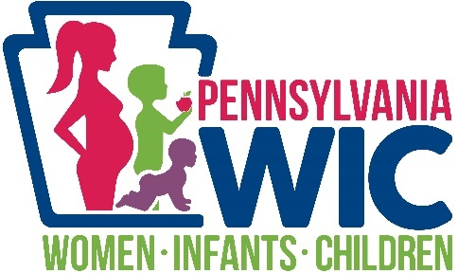

*Women, Infants &*

*Children (WIC)*

The Special Supplemental Nutrition Program for Women, Infants and Children (WIC) is a public health nutrition program under the USDA providing nutrition education, nutritious foods, breastfeeding support, and healthcare referrals for income-eligible women who are pregnant or post-partum, infants, and children up to age 5.

CAPCC WIC has a registered dietitian, registered nurse, nutritionists, and nutrition aides who provide education to all WIC participants throughout their participation on the WIC Program. Participants receive counseling, guidance, and support to achieve healthy lifestyle changes. Our staff monitor relevant indicators such as height, weight, key birth and maternal outcomes and other nutrition-based indicators to ensure participants achieve optimal health outcomes.

An average monthly caseload of 2,111 participants, including 422 infants, 1,245 children, and 444 women (pregnant-185; breastfeeding-98; postpartum-161) were served during FFY22. Over 90% of enrolled, receive benefits each month. Due to the pandemic, CAPCC WIC has been providing services via telehealth, to reach new and existing clients. We utilize drop boxes at all three clinic sites, for eWIC card benefit reloads. Upon the conclusion of the Public Health Emergency and USDA physical presence waivers, CAPCC WIC will open to in-person appointments in addition to offering telehealth options.

WIC offers supplemental nutritious foods via the eWIC card. The eWIC benefit system replaced paper checks in 2019 for overall improvement of program integrity and confidentiality of WIC participants. The WIC Shopper App is available to provide participants with information on WIC vendors, allowable products, recipes and more. During 2022, an enhancement has been added in which participants are now able to view their current benefits.

In addition to the Farmers’ Market vouchers, WIC’s fruit, and vegetable benefit (cash value benefit) was increased to $25 per month for children, $44 per month for pregnant and postpartum participants, and $48 for breastfeeding participants. The current levels of the WIC benefit bump reflect 50 percent of recommended intake under the Dietary Guidelines for Americans.

Supporting breastfeeding in all stages of a mother’s journey is imperative. Whether learning about breastfeeding to make an informed feeding decision or seeking advice to overcome challenges she is facing while breastfeeding, WIC is here to help. Having good support can make all the difference on one’s own journey. Our main form of breastfeeding support is done by the breastfeeding peer counselor making frequent check-ins and forming personal relationships with our participants. Within the past year, we have had an influx of mothers calling the clinic looking for help on their breastfeeding journey. Most of these participants are also seeking help with breast pumps as well.

Through fundraising efforts, the WIC staff provide coats, hats, gloves, and boots to children in need, on a yearly basis. The families are chosen by referrals from agency staff and the community. Each fall, new families attend a shopping day with staff in which the parents and children can pick their own outerwear. Fundraising for this event is ongoing and generous donations are received annually from area businesses and individuals.

***WIC Mission Statement****The Pennsylvania WIC Program is committed to improving the health of eligible pregnant women, new mothers, and children by providing nutrition education, breastfeeding support, healthy foods, and referrals to health and social programs during the critical stages of fetal and early childhood development.*

**Melina Hudec, WIC Program Director**

*List of contributors:*

**AGENCY CONTRIBUTOR LIST:**

**Kotzan CPA and Associates, P.C.**

**Kesslak Benefit Group**

**St. Casimer’s Polski Dom**

**First Commonwealth Bank**

**First National Bank**

**1st Summit Bank**

**Attorney Tim Leventry**

**East Hills Business Association**

**Lockheed Martin Inc.**

**IGA Energy**

**Forest Hills Elementary School**

**EARLY CHILDHOOD CONTRIBUTORS:**

**Admiral Peary Vo-Tech**

**1st Summit Bank of Salix**

**Camtran**

**Central Cambria**

**Christian Appalachian Project**

**Community Foundation for the Alleghenies**

**EARN Job Services**

**Ferndale Area School District**

**Forest Hills School District**

**Foster Grandparents**

**Golden Onsight Dental**

**It’s Worth Repeating**

**Johnstown School District**

**Lakeshore**

**Lamar Advertising**

**Mount Aloysius College**

**Pizza Hut**

**Staples**

**St. Francis University**

**St. Francis Caring and Sharing**

**Valley Printing**

**University of Pittsburgh at Johnstown**

**Walmart**

**Wilkinson’s Bus Lines**

**WIC**

**WJAC**

**VETERAN’S BACKPACK PROJECT:**

**1st Lutheran Church of Johnstown**

**1st Summit Bank**

**Allegheny Orthodontics Associates**

**American Legion Home Association Inc. Post #363**

**American Legion Post #507**

**American Legion Post #128**

**American Legion Unit #460**

**American Legion Vodzak Post #508**

**American Legion Post #970**

**Bedford Grief Support Group**

**Berkebile Towing & Auto**

**C.A.M. CO.**

**Cambria Care Center**

**Conemaugh PNA Lodge #1569**

**Croatian Hall**

**CTC Foundation**

**Dale Oxygen, Inc.**

**Dolan’s Welding & Steel Fabrication, Inc.**

**First Russian American Federation**

**First National Bank**

**Frontier Patriots Chapter of SAR**

**Fraternal Order of Eagles**

**GapVax**

**GroupGenesis**

**Herbert B Daly, VFW Post #5211**

**Herbert CPA & Associates, P.C.**

**Horizon Information Systems, Inc.**

**JWF Industries**

**John White Ex-servicemen Club**

**JPT Architects**

**Moss Creek Ron & Gun Club**

**Ream Miller VFW Post #7783**

**Re-Max Team Realtors**

**Richland American Legion Home Associates**

**Sandybottom Sportsman Club**

**Slovenian Savings & Loan Association**

**VFW Post #4795**

**WIC COATS FOR KIDS’ CONTRIBUTORS:**

**Ace’s Banquets and Catering**

**Altoona Curve**

**Amy Rosenbaum**

**Bakers Loaf**

**Bethany Presbyterian Church**

**Bethany United Methodist Church**

**Cambria County Child Development**

**Carnegie Science Center**

**Cliptations**

**Comfort Inn & Suites**

**Conemaugh Valley Veterans**

**Croatian Hall**

**Cresson Motors, Inc.**

**CTC**

**Dale Oxygen, Inc.**

**Del Grosso’s Park & Laguna Splash**

**Dennis Goldberg**

**Donna Nevins**

**Ebensburg Sheetz**

**1889 Foundation, Inc.**

**Ferndale United Methodist Church**

**First Catholic Slovak Band Hall**

**George Kudrick**

**Greater Johnstown Yellow Cab**

**Horizon Information Systems**

**Hubcaps Pizza**

**Island Cuisine Restaurant**

**The Johnstown Inn**

**JWF Industries**

**Kesslak Financial Group, Inc.**

**Lakemont Park**

**Lee Ann Eckel**

**Living Treasures Wild Animal Park**

**Marie Dumm**

**Mark Semelsburger**

**Mr. Muffler Auto**

**Muzzie Electrical, LLC**

**Nanty Glo Fire Company & Ladies Auxiliary**

**Nanty Glo Moose Lodge 207**

**Noreen Tremel**

**Northwest Bank/Westmont Branch**

**Park Hill American Legion Post 970**

**Pat Krevetski**

**Penmar Veterinary Clinic**

**Pittsburgh Zoo & PPG Aquarium**

**Ray Oil & Gas Company**

**RE/MAX POWER Associates – Sue & Bill Lease**

**Right Elevator**

**Ruff Tymes Band**

**Scoofies Stop and Shop**

**Sidman Sheetz**

**Shaffer Tree Service, LLC**

**Shirley Fasoli**

**Slinky Action Zone**

**Slovenian Savings & Loan Association**

**South Fork VFW**

**Tiffany Wetzel-Sturtz**

**St. Casimirs Polski Dom**

**Summit Country Club**

**T. Christy Auto**

**Team Kia**

**Terry & Darlene Christy**

**Thomas Automotive**

**Thomas Feed Mill**

**UPMC Altoona**

**Von’s United Beverage**

**VFW Post 1586**

**Wessel & Company**

**WJAC-TV**

***What is Community Action?***

1. Community Action Agencies are non-profit private and public organizations established under the Economic Opportunity Act of 1964 to fight America’s “War on Poverty.”
2. Community Action Agencies provide services and assistance towards the elimination of poverty though developing self-sufficiency opportunities, improving human performance, motivation, and productivity, or bettering the conditions under which people live, learn and work. Community Action Agencies help people to help themselves in achieving self-sufficiency.
3. The Community Services Block Grant (CSBG) is the agencies’ core federal funding. Agencies also operate a variety of grants that come from federal, state and local sources.
4. Community Action Agencies provide a broad range of services and activities; typical activities include promoting client participation, providing financial assistance for low-income individuals, administration of Head Start pre-school programs, WIC services, Drug & Alcohol prevention, transportation assistance and other community-based initiatives.
5. Community Action Agencies are connected by a national network that includes the Community Action Partnership national association, other national associations, state CAAP, a national lobbying association and a national association of Community Service Block Grant administrators.
6. Today there are approximately 1,000 Community Action Agencies serving the poor in every state.
7. The service areas of Community Action Agencies cover 96 percent of the nation’s counties.
8. Community Action Agencies are a primary source of support for the more than 34.5 million people who live in poverty in the United States.

516 Main Street

Johnstown, PA 15901

Phone: (814) 536-9031

Fax: (814) 539-5813

[www.capcc.us](http://www.capcc.us)

www.facebook.com/capcambriacounty